**CHENEY’S ALGORITHM vs MARK-COMPACT ALGORITHM**

CHENEY’S ALGORITHM :

Cheney’s algorithm is a type of a garbage collector algorithm where the heap is divided into two equal halves in which only one half of the heap is used at any time.

Garbage collection is done by copying live objects from one space or one heap to another space or another heap and the previous heap is destroyed.

MARK-COMPACT ALGORITHM :

Mark – Compact algorithm is also type of a garbage collector algorithm which is used to reclaim the unreachable memory. It can eliminate fragmentation in order to have a compacted heap.

The main advantage of compacted heap is the allocation process will be very fast and adjacent objects can be benefit from CPU cache.

**STEP 1 :-**  Tracing the live objects.

**STEP 2 :-**  Transmit to or send the live objects to available memory locations.

**STEP 3 :-**  Update the references to point to new objects location.

I have implemented both the algorithms in C Language to get the time complexity.

***CHENEY’S ALGORITHM :-***

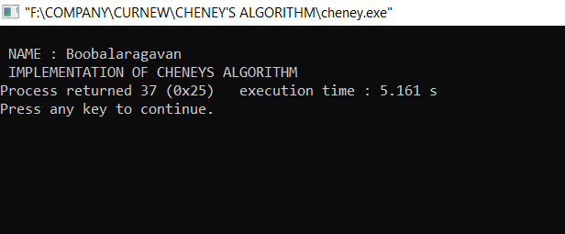

*From the above image we could see that cheney’s algorithm takes approximately 5 to 6 seconds time for execution.*

***MARK – COMPACT ALGORITHM :-***

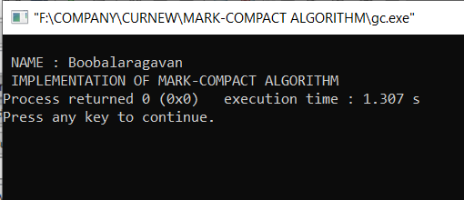

*From the above image we could see that mark-compact algorithm takes approximately 1 to 2 seconds time for execution.*

COMPARISON :-

When comparing both the algorithms it is clear that “Mark-compact” algorithm is more efficient and better. Because,

* When we view in the point of Complexities it takes less space and time when compared to Cheney’s algorithm.
* Also in Mark-compact algorithm the unreachable memory is gained and the unused objects were removed. So it is more efficient.